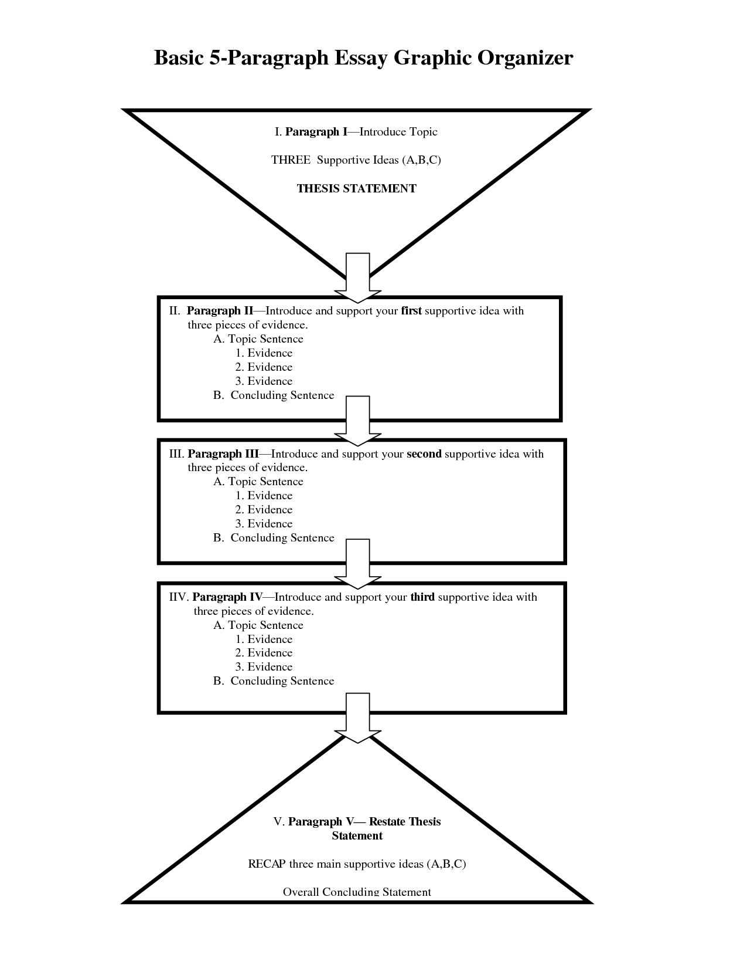

**What is a cell?**

Explain and define what a cell is and why it is important.

**Compare animal & plant cells:**

3 similarities. Explain and define these.

**Contrast animal & plant cells:**

2-3 differences. Explain and define these.

Turn essay question into statements. Don’t ask questions.

\***No Sentences** for your outline.

*No Contractions

*No 1st Person

*No 2nd Person

**Essay Question:**

Compare and contrast animal and plant cells. Name at least three similarities and at least two differences. Explain how these contribute to the differences in plants and animals themselves. (Explain why they are needed.)